AI-Powered Fresher Job Discovery and Tracking System
1. Project Overview
The AI-Powered Fresher Job Discovery and Tracking System is an automated workflow developed using n8n to help fresh graduates discover entry-level job opportunities efficiently. The system eliminates the need for manually searching multiple job portals by automatically collecting job information based on user input and storing the results in Google Sheets for easy tracking.
The workflow accepts a job role and location from the user through an online form, searches the web for relevant job opportunities, extracts useful job information, and automatically records the results in a structured format.

2. Problem Statement
Fresh graduates and entry-level job seekers often struggle to find relevant job opportunities because companies use different terms to describe beginner-level positions. While some organizations use terms such as "Fresher" or "Entry Level," others advertise similar roles as "Trainee," "Graduate Program," "Associate," "Junior Analyst," "Analyst I," "Campus Hiring," or "Early Career."
As a result, job seekers must manually search multiple job portals and company career pages using different keywords, making the process time-consuming and inefficient.
Additionally, relevant opportunities are scattered across platforms such as LinkedIn, Indeed, Foundit, Naukri, and company career websites. Manually visiting each platform, searching for suitable roles, and tracking job links requires significant effort and often causes candidates to miss opportunities.
This project aims to develop an AI-powered automated job discovery system that allows users to provide only a job role and preferred location. The system automatically expands the search using fresher-related keywords, collects job opportunities, and stores the results in a centralized Google Sheet for easy access and tracking.

3. Objectives
Primary Objective
To automate the process of discovering and tracking fresher and entry-level job opportunities.
Secondary Objectives
- Reduce manual effort in job searching.
- Collect job information from online sources automatically.
- Store job opportunities in a centralized repository.
- Improve accessibility of job opportunities for fresh graduates.
- Enable future integration with multiple job portals.

4. System Architecture
User Form
↓
n8n Form Trigger
↓
HTTP Request (SerpAPI)
↓
JavaScript Processing
↓
Google Sheets

5. Workflow Description
Step 1: User Input Form
The user submits:
- Job Role
- Location
Example:
Job Role: Data Analyst
Location: India
The form acts as the starting point of the workflow.

Step 2: Form Submission Trigger
The n8n Form Trigger receives the submitted data and initiates the workflow automatically.
Example Output:
{
"job_role": "Data Analyst",
"location": "India"
}

Step 3: HTTP Request Node
The HTTP Request node sends a search query to SerpAPI.
Example Search Query:
Data Analyst jobs India
The node retrieves job-related search results from Google.

Step 4: JavaScript Processing Node
The Code node processes the API response and extracts:
- Job Title
- Job Link
- Source
- Job Description Snippet
Example:
{
"title": "Entry Level Data Analyst Jobs",
"link": "https://example.com/job",
"source": "Indeed",
"snippet": "Entry-level Data Analyst opportunity..."
}

Step 5: Google Sheets Storage
The processed data is automatically appended to a Google Sheet.
Stored Columns:
Column
title
link
source
snippet
This allows users to maintain a searchable and organized job database.

6. Technologies Used
Technology | Purpose
n8n | Workflow Automation
SerpAPI | Job Search Data Retrieval
JavaScript | Data Processing
Google Sheets | Data Storage
Google Cloud Service Account | Authentication
Google Sheets API | Spreadsheet Integration

7. Features Implemented
Completed Features
- User Input Form
- Automated Workflow Trigger
- Job Search Integration
- Search Result Processing
- Google Sheets Integration
- Automatic Data Storage
- End-to-End Automation

8. Sample Output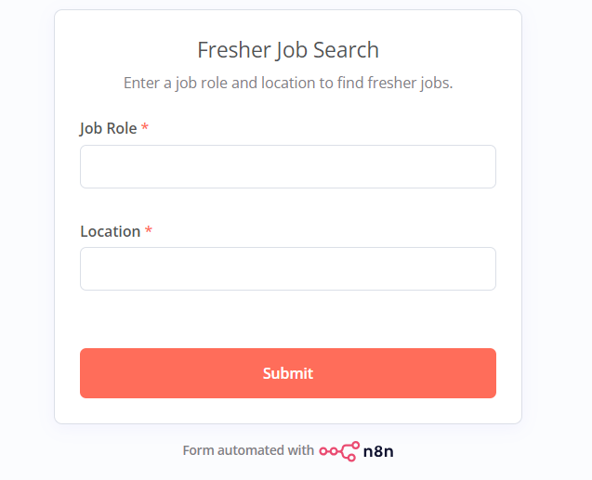
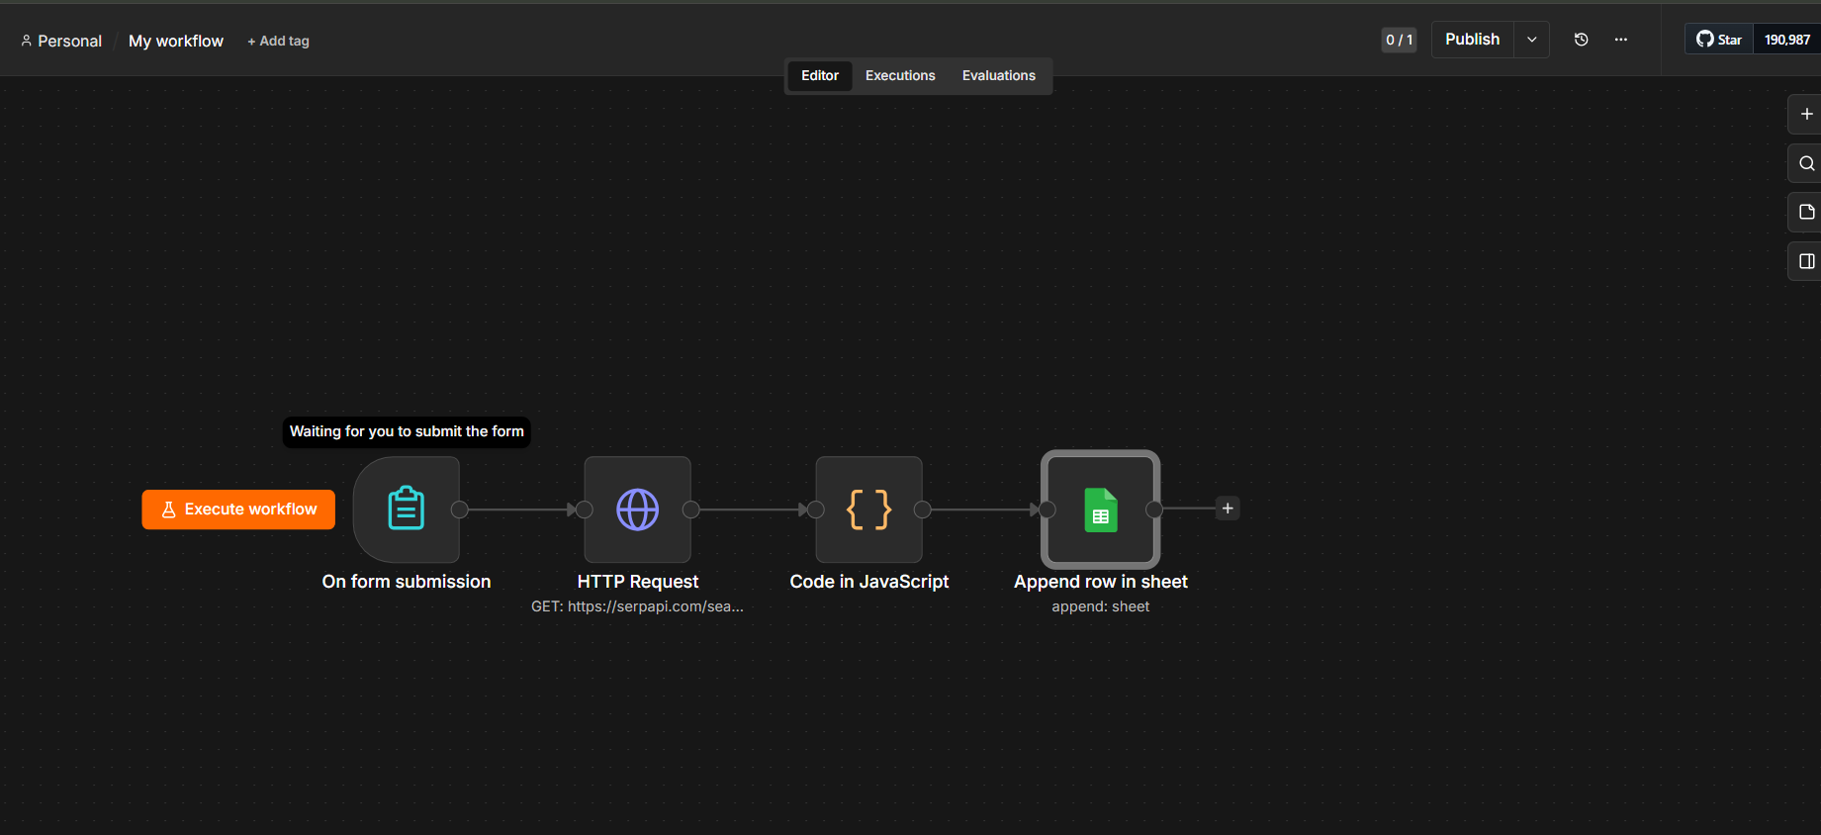
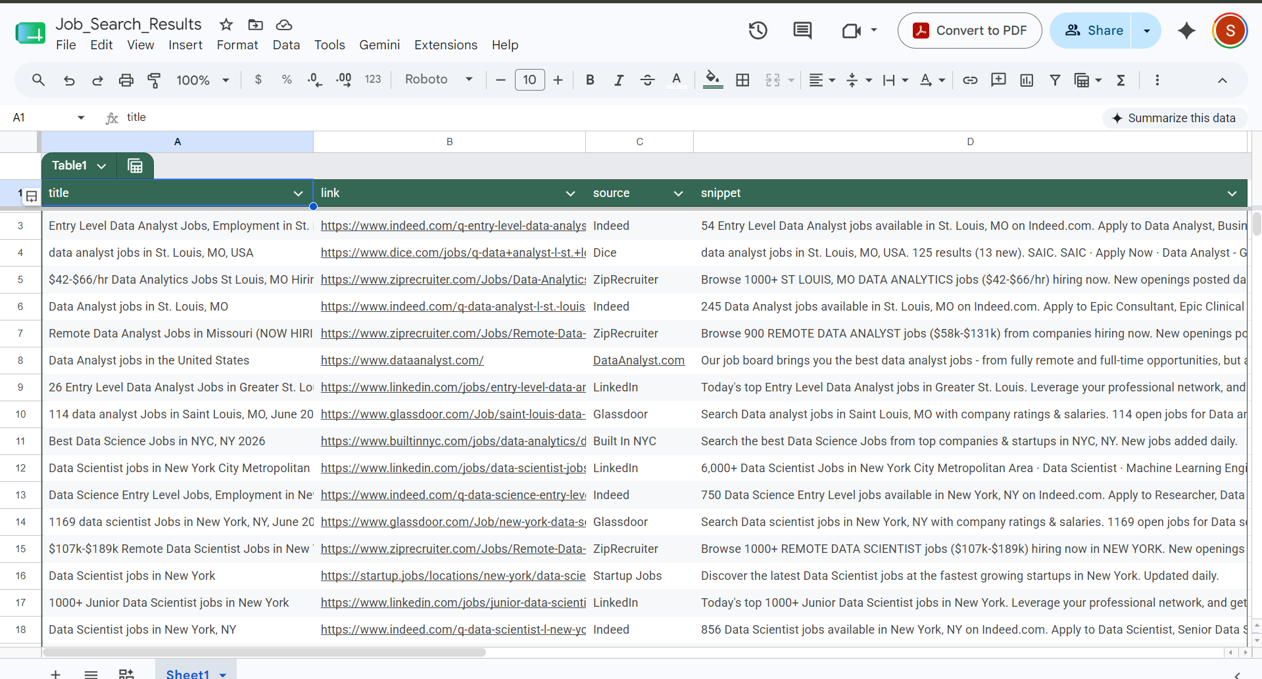
9. Benefits
- Saves time during job searching.
- Centralizes job opportunities in one place.
- Reduces repetitive manual searching.
- Supports fresh graduates seeking entry-level roles.
- Easily scalable for additional job portals.

10. Future Enhancements
Planned Improvements
- Search multiple platforms:
  - LinkedIn
  - Naukri
  - Foundit
  - Indeed
  - Company Career Pages
- Automatic duplicate removal.
- AI-based job ranking.
- Remote job filtering.
- Daily email notifications.
- Resume-to-job matching.
- Dashboard for job analytics.

11. Conclusion
The AI-Powered Fresher Job Discovery and Tracking System successfully automates the process of finding and organizing entry-level job opportunities. By integrating n8n, SerpAPI, JavaScript, and Google Sheets, the system provides a centralized and automated solution that reduces manual effort and improves job discovery efficiency for fresh graduates seeking employment opportunities.
This project demonstrates practical application of workflow automation, API integration, data processing, and cloud-based storage to solve a real-world problem faced by job seekers.

